Accessing the Google Authenticator for Simplybook Booking Platform for managing the Covid 19 Vaccination Appointments
To support the Covid-19 vaccination delivery
Contents
1 Definition and Purpose 3
2 Accessing Google Authenticator 3
2.1 Getting Started 3
3 Linking Google Authenticator with Simplybook Account 3
3.1 New User Email Notification 3
3.2 Setting a New Password 4
3.3 Log In Success 4
3.4 Adding Google Authenticator Security 4
3.5 User account linked 5
3.6 Google Authenticator Reset 5

- Definition and Purpose
This booklet sets out the operational processes for setting up Google Authenticator to support a 2 –stage authentication process for accessing Simplybook.
Should you not be able to find the support you require within this document, please contact the jbs.enquiries@miaa.nhs.uk mailbox, where one of the team will be able to assist.
- Accessing Google Authenticator
  - Getting Started

Firstly, on the mobile device that is going to have the Google Authenticator App installed, open the application store (Google Play or App Store):

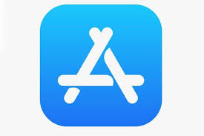
Search for ‘Google Authenticator’, or enter:
- https://play.google.com/store/apps/details?id=com.google.android.apps.authenticator2&hl=en_GB
- https://apps.apple.com/us/app/google-authenticator/id388497605

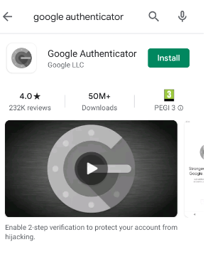
then tap ‘install’.

- Linking Google Authenticator with Simplybook Account
  - New User Email Notification
Once a user account for Simplybook has been created, you will be sent a notification to the email address provided to your clinic system administrator.
The email will confirm your username, and a link. The link is time sensitive, so it you are unable to access within 3 hours after receiving the link, you will need to request that a new link is sent.
  - Setting a New Password
On accessing the accessing the link, a pop up message will appear, confirming if you would like to set a new password. Click ‘Continue’
A pop-up for Terms and Condition privacy policy:

If you agree to the terms, check the boxes and click ‘Continue’
When prompted, enter your new password when prompted. Passwords must fulfil the following criteria:
- Be at least 15 characters long
- Contain at least 1 x Upper and 1 x Lower character
- Contain at least one numerical or special character (e.g. $%*&)
  - Log In Success
On accessing the booking system after your first log in you will be directed to the welcome page:
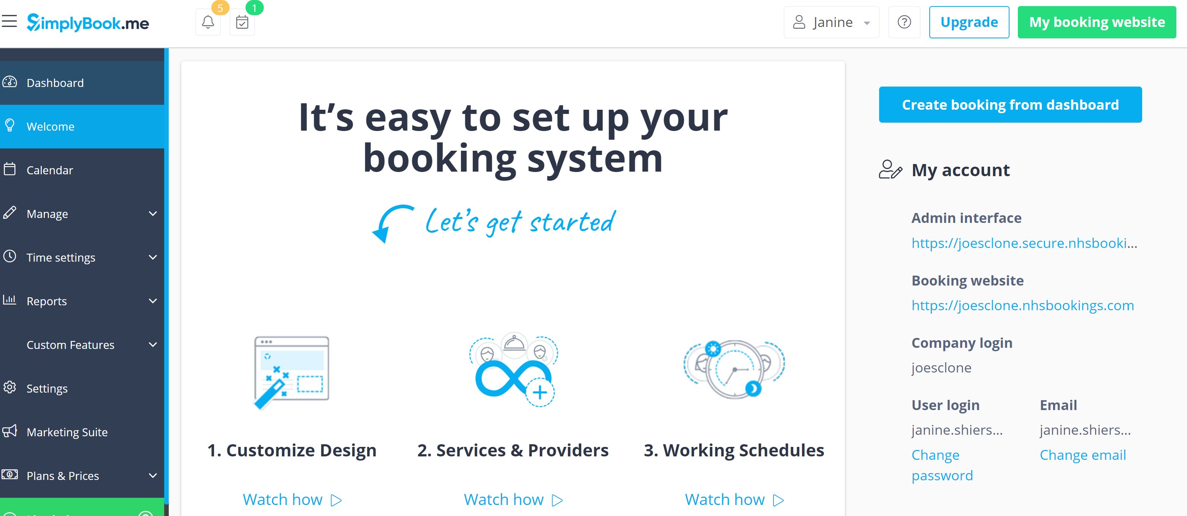

  - Adding Google Authenticator Security
After accessing Simplybook for the first time, you will need to add Google Authenticator security to your user account if you have access to PID (patient identifiable information) – user level POS and above.
Using the side menu bar, click on the Welcome page

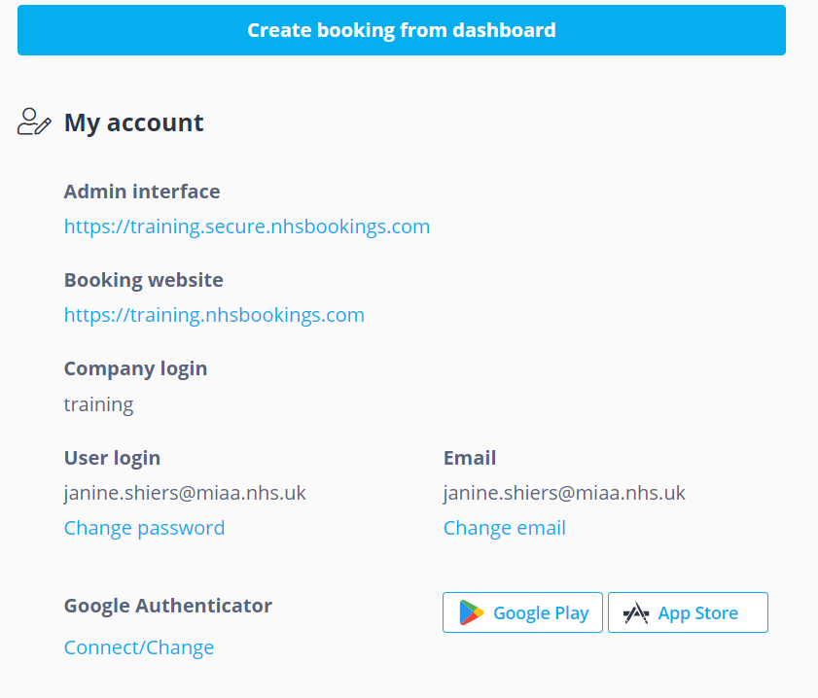
On the right-hand side under, you will see your account details.
Click on ‘Connect/Change’ under ‘Google Authenticator’
This will bring up a QR Code.
Using the mobile device with Google Authenticator installed, open the app.
Click Add (+), select ‘scan a QR code’ (or manual entry) from the menu and use the phones camera to scan the QR code from the authenticator app. icon.
This will add a new Google Authenticator account, a 6 digit number that changes every 30 seconds.
  - User account linked
The account is now linked with Google Authenticate. The next time you log into the Simplybook account you will be prompted to add the 6 digit Google Authenticate. This code changes every 30 seconds
  - Google Authenticator Reset
If you lose or delete your google authenticator account, you will need to contact your system adminstrator for simplybook to reset your account.

